In this activity, you will use the Redis and NiFi installations from [Mini-Lesson 17.5](https://classroom.emeritus.org/courses/10605/pages/mini-lesson-17-dot-5-installing-nifi-and-redis-from-source-60-00) to create an ETL pipeline that will populate your database with the current date and time. You will begin by launching both Redis and NiFi. Next, you will populate your NiFi *flow* with all the *controllers* and *processors* needed for the ETL process. Finally, you will be asked to verify that your database is being populated correctly.

Before starting this activity, review the submission instructions below to ensure that you collect the required screenshots as you progress through the activity.

**To complete this activity, follow these steps:**

1. In a Terminal window, type the correct commands for your operating system to start Redis by following the steps in [Mini-Lesson 17.5](https://classroom.emeritus.org/courses/10605/pages/mini-lesson-17-dot-5-installing-nifi-and-redis-from-source-60-00).  
   Provide a screenshot of your Terminal window to show that you successfully started Redis.
2. In a new Terminal window, start NiFi using the commands for your operating system by following the steps in [Mini-Lesson 17.5](https://classroom.emeritus.org/courses/10605/pages/mini-lesson-17-dot-5-installing-nifi-and-redis-from-source-60-00). Provide a screenshot of your Terminal window to show that you successfully started NiFi.
3. Navigate to https://localhost:8443/nifi to open the NiFi UI. Provide a screenshot to show that you successfully opened the NiFi UI.
4. In the NiFi Flow process group, select the gear icon to configure the NiFi Flow process group. In the CONTROLLER SERVICES tab, select the plus sign and select RedisConnectionPoolService as the type.

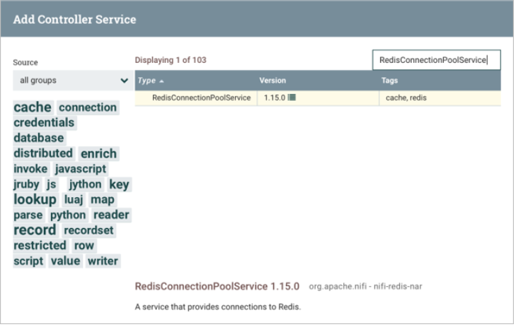In the PROPERTIES tab, set the Connection String *property* equal to localhost:6379. Do not change any other default values. Provide a screenshot to show that you set the RedisConnectionPoolService *controller* settings correctly.

5. Inside the NiFi Flow process group, add another *controller* named RedisDistributedMapCacheClientService.

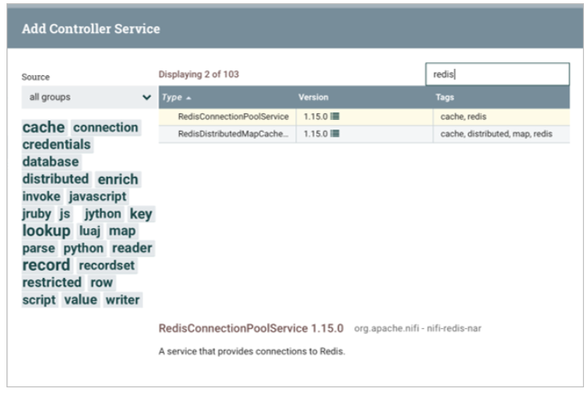

In the PROPERTIES tab, select the RedisConnectionPoolService *controller* created in the previous step. Provide a screenshot to show that you set the RedisDistributedMapCacheClientService *controller* settings correctly.

6. Enable your *controllers*. Provide a screenshot to show that you enabled both the RedisConnectionPoolService and RedisDistributedMapCacheClientService *controllers.*

7. Create a *processor* titled GenerateFlowFile*.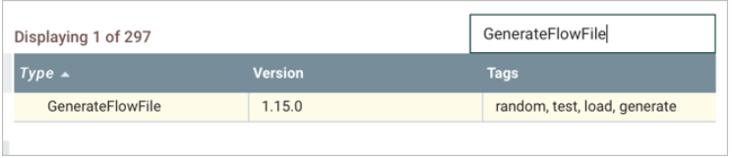*

In the PROPERTIES tab, set the Custom Text *property* to ${now()}. This will put the current date and time into the content of each FlowFile. In the SCHEDULING tab, change the Run Schedule to five seconds.  
Provide two screenshots. The first screenshot should show that you set the values in the PROPERTIES tab correctly. The second screenshot should show that you updated the scheduling time in the SCHEDULING tab correctly.

8. Create a *processor* titled PutDistributedMapCache*.*

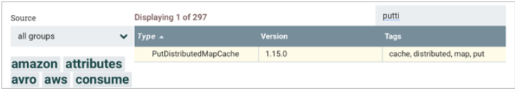

In the PROPERTIES tab, set the Distributed Cache Service equal to Redis DMC Client Service. Set the Cache Entry Identifier equal to date. This will be your Redis *key*. Provide a screenshot to show that you set the PutDistributedMapCache *controller* settings correctly.

9. Create a *processor* titled FetchDistributedMapCache*.*

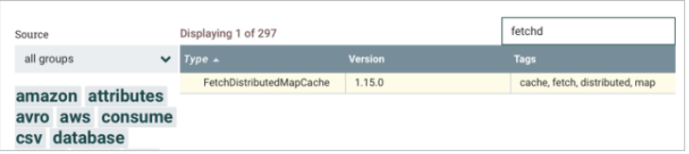

In the PROPERTIES tab, set the Distributed Cache Service equal to Redis DMC Client Service. Set the Cache Entry Identifier equal to date and the Put Cache Value in Attribute equal to date.retrieved. Provide a screenshot to show that you set the FetchDistributedMapCache *controller* settings correctly.

10. Create a *processor* titled LogAttribute*.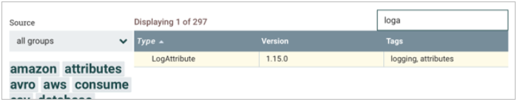*

Provide a screenshot to show that you have all the *controllers*, GenerateFlowFile*,* PutDistributedMapCache, FetchDistributedMapCache, and LogAttributeready in NiFi.

11. Connect all your *processors* in the order they were added by using success as the relationship type. Ensure the following:

* 1. In the PutDistributedMapCache *processor* settings, set Automatically Terminate Relationships equal to failure.
  2. In the FetchDistributedMapCache *processor* settings, set Automatically Terminate Relationships equal to failure and not-found.
  3. In the LogAttribute *processor* settings, set Automatically Terminate Relationships equal to success.

Run the *flow*. Provide a screenshot to show that your *flow* is running with the correct relationships.

12. In the Terminal window, navigate to the logs folder inside the libexec folder and open the nifi-app.log file by using the nano text editor.  
Provide a screenshot to show that the nifi-app.log is being populated with the current date and time.

**Submission Instructions:**

Your submission for this activity should be a Word document that includes the following screenshots, each labeled for the step that the screenshot represents:

1. Provide a screenshot of your Terminal window to show that you successfully started Redis.
2. Provide a screenshot of your Terminal window to show that you successfully started NiFi.
3. Provide a screenshot to show that you successfully opened the NiFi UI.
4. Provide a screenshot to show that you set the RedisConnectionPoolService *controller* settings correctly.
5. Provide a screenshot to show that you set the RedisDistributedMapCacheClientService *controller* settings correctly.
6. Provide a screenshot to show that you enabled both the RedisConnectionPoolService and RedisDistributedMapCacheClientService *controllers.*
7. Provide two screenshots. The first screenshot should show that you set the values in the PROPERTIES tab correctly. The second screenshot should show that you updated the scheduling time in the SCHEDULING tab correctly.
8. Provide a screenshot to show that you set the PutDistributedMapCache *controller* settings correctly.
9. Provide a screenshot to show that you set the FetchDistributedMapCache *controller* settings correctly.
10. Provide a screenshot to show that you have all the *processors*, GenerateFlowFile*,* PutDistributedMapCache, FetchDistributedMapCache, and LogAttribute,ready in NiFi.
11. Provide a screenshot to show that your *flow* is running with the correct relationships.
12. Provide a screenshot to show that the nifi-app.log is being populated with the current date and time.